**Experiment 2: Half adder and Full adder Implementation in VHDL.**

**Digital Systems Design Lab**



**Submitted To: Submitted By:**

**Dr. Rajiv Verma Gaurav Yadav**

**Assistant Professor CSE**

**IIIT Sonepat 11911038**

* **VHDL Source Code for Half Adder and Full Adder:**

--BY Gaurav Yadav | 11911038 | CSE

Library ieee;

use ieee.std_logic_1164.all;

entity half_adder is

port(a1,b1:in bit;

sum1,carry1:out bit);

end half_adder;

entity full_adder is

port(a2,b2,c2:in bit;

sum2,carry2:out bit);

end full_adder;

architecture data of full_adder is

begin

sum2<= a2 xor b2 xor c2;

carry2 <= ((a2 and b2) or (b2 and c2) or (a2 and c2));

end data;

architecture data of half_adder is

begin

sum1<= a1 xor b1;

carry1 <= a1 and b1;

end data;

* **Output Waveform of Half Adder:**

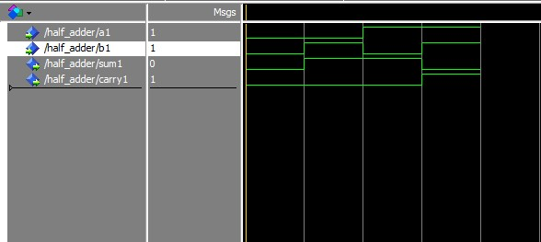

* **Output Waveform of Full Adder:**

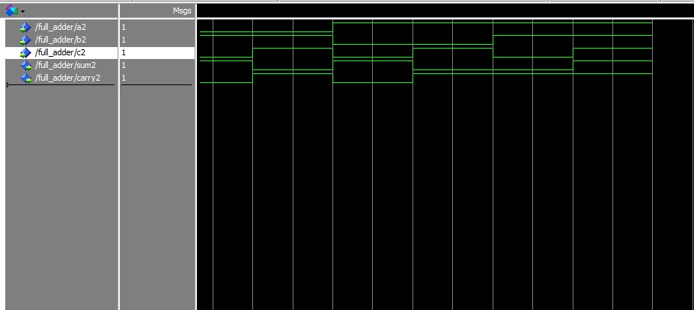

* **Result:**

With the help of this experiment, we are able to understand the behaviour of half adder and full adder digitally.